Hands On10: **Solution**

Install AWS Toolkit for Visual studio 2019

1. Click on the below link to install AWS Toolkit for VS 2019

<https://aws.amazon.com/visualstudio/>

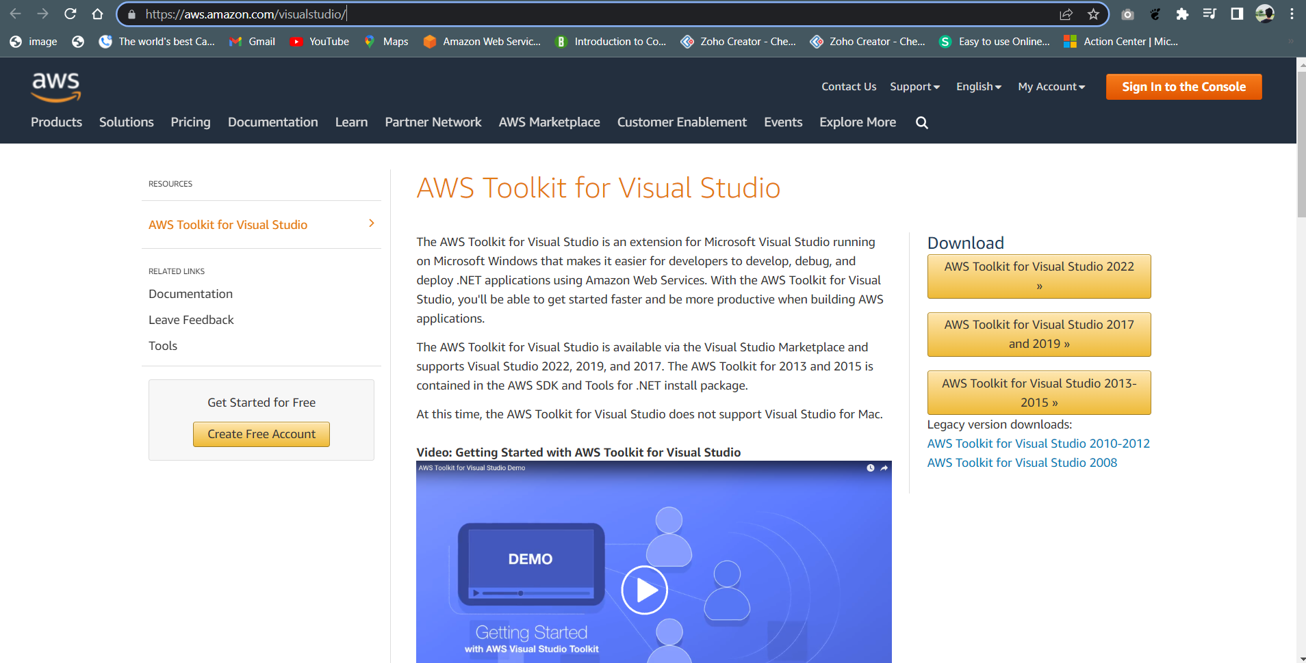

2. Choose VS 2019 in the screen and click on the download button to install the AWS toolkit for VS 2019. The below link will have the “download” button.

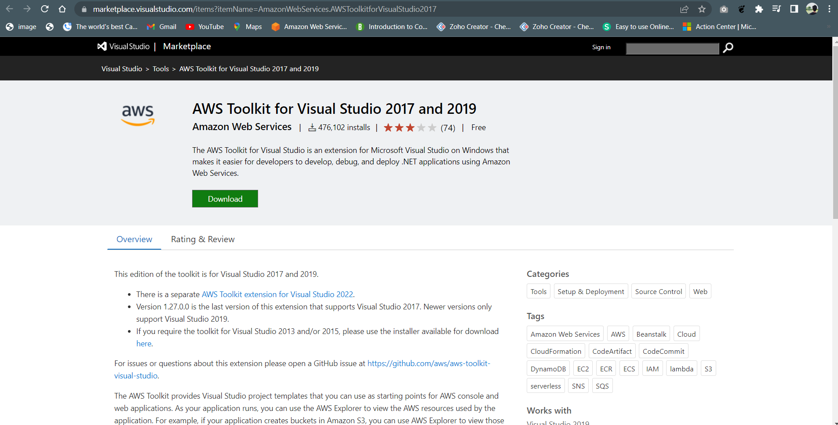

3. After download the file, click “Install”

4. Open Visual Studio 2019 and find the following screen while trying to create a new project.

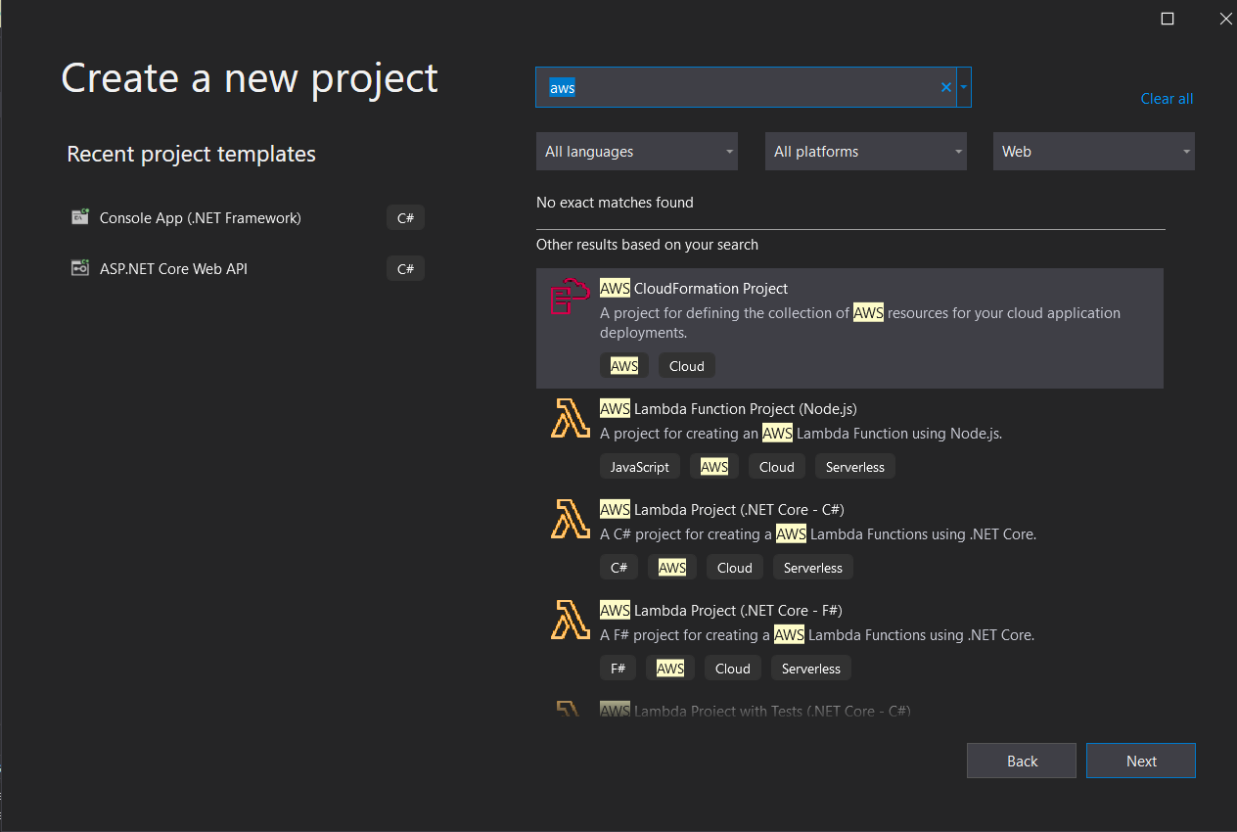

5. AWS Toolkit is installed in VS 2019 Successfully.